**Mongodb Assignment-2**

**Exercise1:**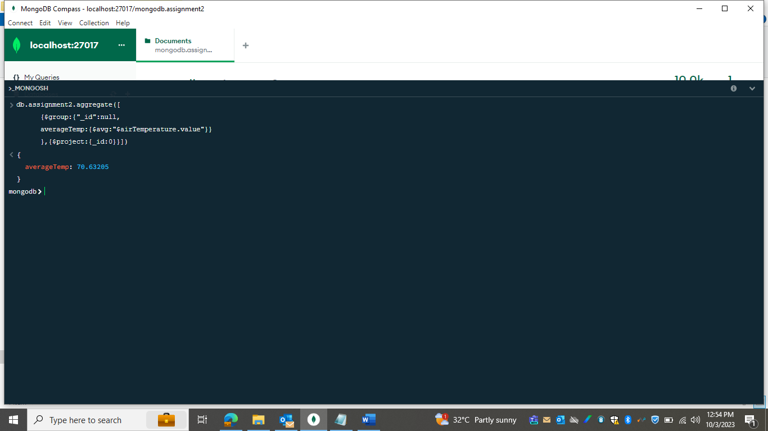

Exercise2

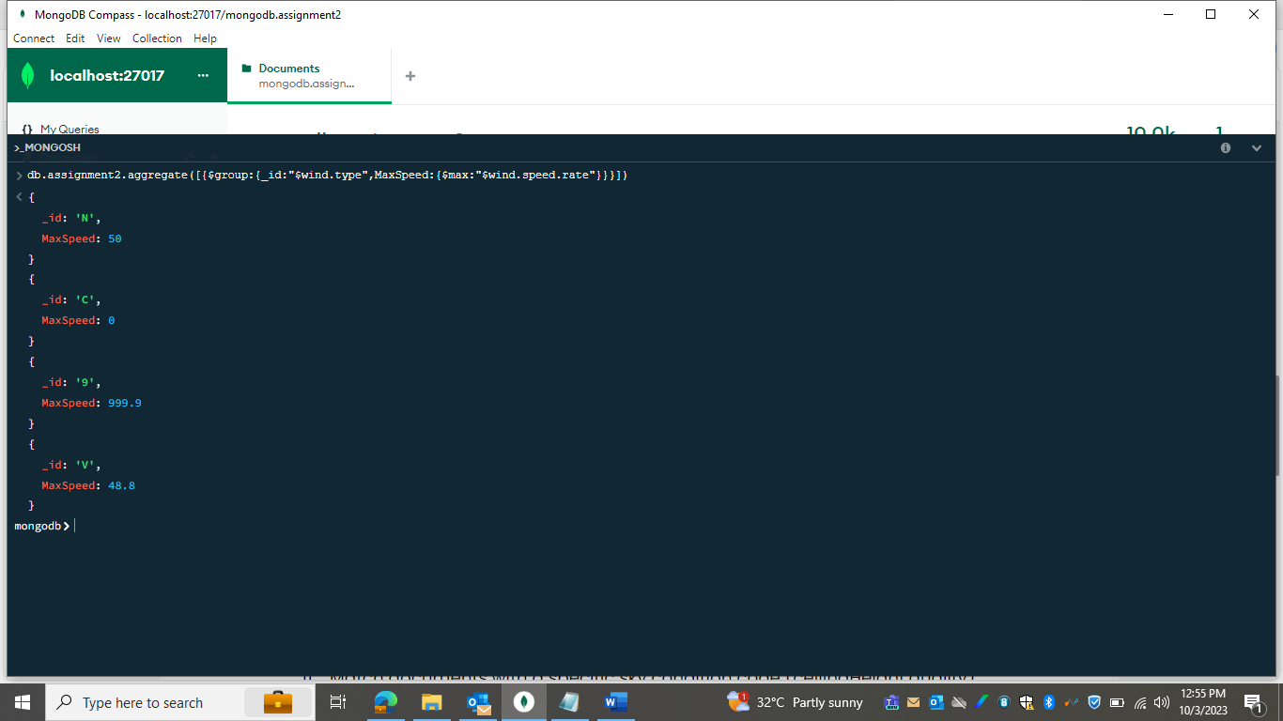

Exercise3:

Exercise4:

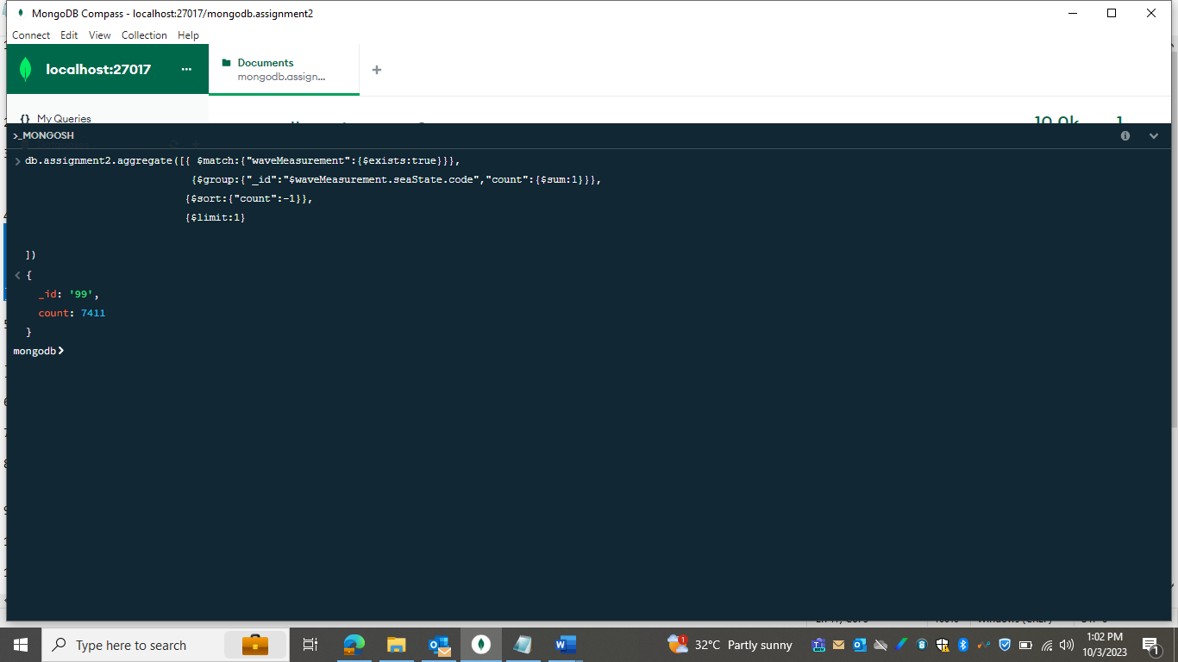

Exercise5:

Exercise6:

Exercise7:

Exercsie8:

Exercise9:

Exercise10:

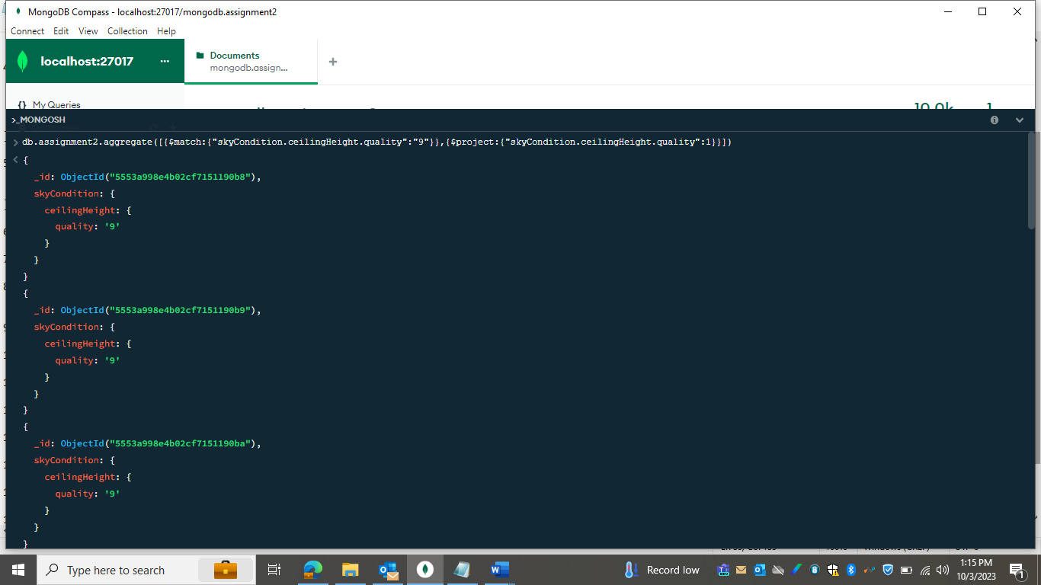Exercise11:

Exercise12:

Exercise13:

Exercise14:

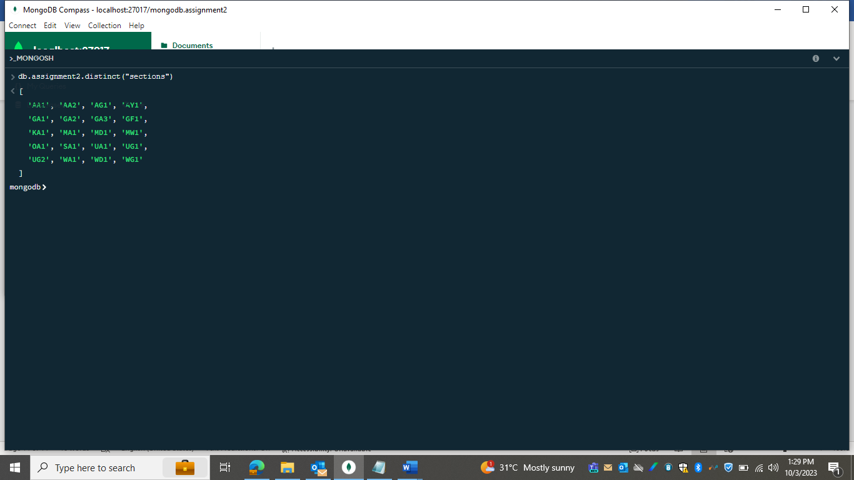

Exercise15:

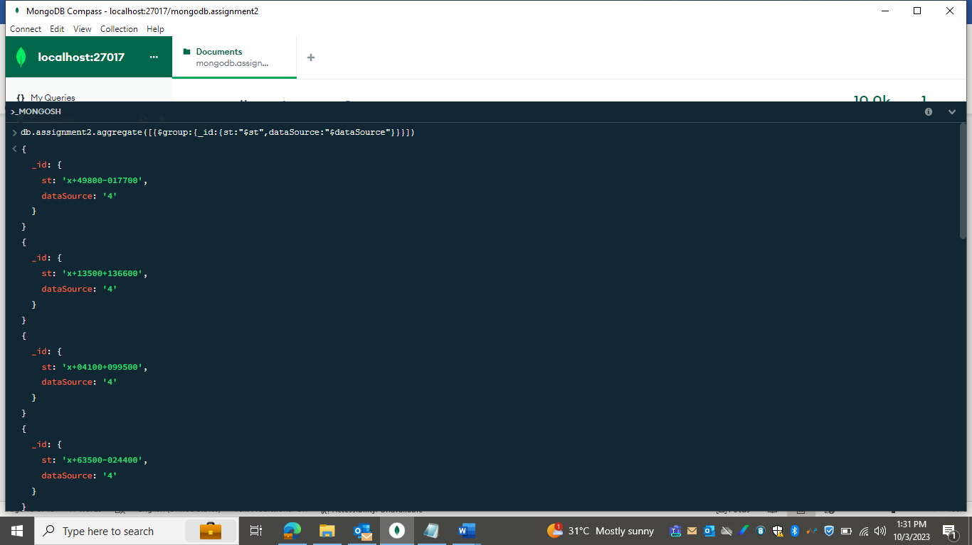

Exercise16:

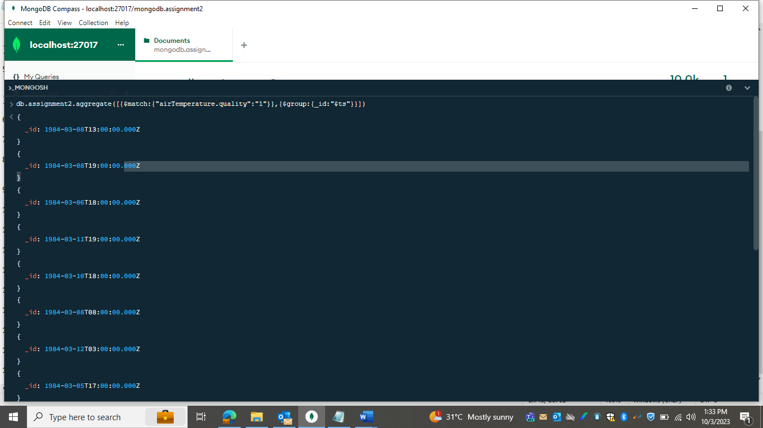

Exercise17:

